THE UNIVERSITY OF SOUTH ALABAMA
COLLEGE OF ARTS AND SCIENCES

[Title]

BY

Jack Shelley-Tremblay

A Thesis

Submitted to the Graduate Faculty of the
University of South Alabama
in partial fulfillment of the
requirements for the degree of

Master of Science

in

Psychology

Month, Year (of graduation)

Approved: Date:

Chair of Thesis Committee: Dr. First Name, Middle Initial, Last Name

________________________________________________________________________
Committee Member: Dr. First Name, Middle Initial, Last Name

________________________________________________________________________
Committee Member: Dr. First Name, Middle Initial, Last Name

________________________________________________________________________
Chair of Department: Dr. First Name, Middle Initial, Last Name

________________________________________________________________________
Director of Graduate Studies: Dr. Eric Loomis

________________________________________________________________________ Dean of the Graduate School: Dr. J. Harold Pardue

[Title]

A Thesis

Submitted to the Graduate Faculty of the
University of South Alabama

in partial fulfillment of the
requirements for the degree of

Master of Science

in

Psychology

by
Your Name
B. S., (Undergraduate University)
Month, year (of graduation)

Acknowledgments
If there is anyone you would like to thank, this should go here. This page is optional. If you wish to include a dedication, keep it brief and center it in the center of the page with no heading. If a dedication is used (also optional), it will be page ii and the Acknowledgement will be page iii. Delete this page if you aren’t planning to use it.

Table of Contents
List of Tables iv
List of Figures v
List of Abbreviations vi
Abstract vii
[Title Here, up to 12 Words, on One to Two Lines] 1
[Heading 1] 1
[Heading 2] 1
[Heading 3]. 1
[Heading 4]. 1
References 3
Footnotes 4
Tables 5
Figure 1. 6
Biographical Sketch 7
Appendix (A through Z) 8

List of Tables
Table 1 5

List of Figures
Figure 1. 6

List of Abbreviations

Abstract
Your last name, first name, middle name or initial if applicable, M. S., University of South Alabama, December 2013. The Title of Your Paper. Chair of Committee: First Name, Last Name, Ph.D.

If this is a thesis, the abstract may only be one page in length. If this is a dissertation, it may be two pages in length.

[The abstract should be one paragraph of between 150 and 250 words. It is not indented. Section titles, such as the word Abstract above, are not considered headings so they don’t use bold heading format. Instead, use the Section Title style. This style automatically starts your section on a new page, so you don’t have to add page breaks. Note that all of the styles for this template are available on the Home tab of the ribbon, in the Styles gallery.]

Keywords: [Click here to add keywords.]

[Title Here, up to 12 Words, on One to Two Lines]
[The body of your paper uses a half-inch first line indent and is double-spaced. APA style provides for up to five heading levels, shown in the paragraphs that follow. Note that the word Introduction should not be used as an initial heading, as it’s assumed that your paper begins with an introduction.]

[Heading 1]
[The first two heading levels get their own paragraph, as shown here. Headings 3, 4, and 5 are run-in headings used at the beginning of the paragraph.]

[Heading 2]1
[To add a table of contents (TOC), apply the appropriate heading style to just the heading text at the start of a paragraph and it will show up in your TOC. To do this, select the text for your heading. Then, on the Home tab, in the Styles gallery, click the style you need.]

[Heading 3].
[Include a period at the end of a run-in heading. Note that you can include consecutive paragraphs with their own headings, where appropriate.]

[Heading 4].
[When using headings, don’t skip levels. If you need a heading 3, 4, or 5 with no text following it before the next heading, just add a period at the end of the heading and then start a new paragraph for the subheading and its text.] (Last Name, Year)

[Heading 5].
[Like all sections of your paper, references start on their own page. The references page that follows is created using the Citations & Bibliography feature, available on the References tab. This feature includes a style option that formats your references for APA 6th Edition. You can also use this feature to add in-text citations that are linked to your source, such as those shown at the end of this paragraph and the preceding paragraph. To customize a citation, right-click it and then click Edit Citation.] (Last Name, Year)

References
Last Name, F. M. (Year). Article Title. Journal Title, Pages From - To.
Last Name, F. M. (Year). Book Title. City Name: Publisher Name.

Footnotes
1[Add footnotes, if any, on their own page following references. For APA formatting requirements, it’s easy to just type your own footnote references and notes. To format a footnote reference, select the number and then, on the Home tab, in the Styles gallery, click Footnote Reference. The body of a footnote, such as this example, uses the Normal text style. (Note: If you delete this sample footnote, don’t forget to delete its in-text reference as well. That’s at the end of the sample Heading 2 paragraph on the first page of body content in this template.)]

Tables
Table 1
[Table Title]
Column Head | Column Head | Column Head | Column Head | Column Head
Row Head | 123 | 123 | 123 | 123
Row Head | 456 | 456 | 456 | 456
Row Head | 789 | 789 | 789 | 789
Row Head | 123 | 123 | 123 | 123
Row Head | 456 | 456 | 456 | 456
Row Head | 789 | 789 | 789 | 789
Note: [Place all tables for your paper in a tables section, following references (and, if applicable, footnotes). Start a new page for each table, include a table number and table title for each, as shown on this page. All explanatory text appears in a table note that follows the table, such as this one. Use the Table/Figure style, available on the Home tab, in the Styles gallery, to get the spacing between table and note. Tables in APA format can use single or 1.5 line spacing. Include a heading for every row and column, even if the content seems obvious. A default table style has been setup for this template that fits APA guidelines. To insert a table, on the Insert tab, click Table.]

Figures
Figure 1.
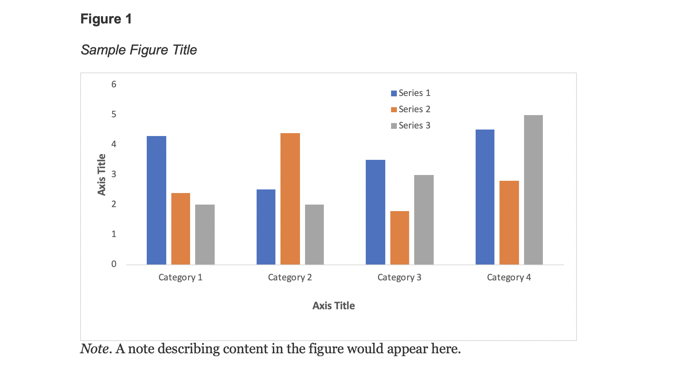
Figures may be embedded in the manuscript(APA Student Style) text or included at the end. If they appear at the end, make sure each figure appears on its own page. This is APA 7th ed. Professional Style. Figures at the end of the document appear after references, footnotes, and tables. Include a numbered caption for each figure. Use the style called Figure Heading in the styles list.
For more information about all elements of APA formatting, please consult the APA Style Manual, 7th Edition.

Biographical Sketch

Appendix (A through Z)
Student must include IRB approval (must be a screen grab, stamped).

